July 12, 2023
Committee Reports
Audit – Patti
Audit done, financial statements correct for May/June
Banquet Committee Report – Patti
The banquet will be Nov 12th and a time is to be determined. Location Argykos in Portage. Email is going out for save the date and donation requests.
Bylaws – Janice
Nothing to report
Clinic committee report – Amanda
I have been in contact with Ida Norris. I think we can get something worked out. I reached out to The Dressage Foundation to see if they offer any grants that we could use since we are offering both seats, and most grants are specific to English or Western. We have one that may work as long as we build in some lecture or demo and really focus on the auditor/educational experience. I will work with Ida to see what our options are, but I am sure we can make this an amazing (and hopefully two day) event that is affordable for members. I am waiting to hear from Pine Lake if they are available for hosting. Willow Ridge is pretty full for the weekends Ida had available.

I'm also working with Kim Dunlap to set up a spring long lining clinic at her facility.

L Program is continuing ahead. We have I believe 11 registered participants with 5 more potentials on the way. I emailed all regional GMO presidents (thank you Carmen for putting that list together!) and asked them to share it with their groups. We will also continue to promote with local trainers and their students. I expect the numbers will grow as it draws closer. Janice has been a great help organizing everything.

Our saddle fit and body work clinics also went over well. I'd like to have another "smaller" clinic like that. I am open to ideas for topics or presenters. We could also offer one again for the people who missed it or it filled the first time.

GLASS-ED Annual Show committee report – Mary
2 judges just over 7 hours each. 49 horse/rider entries. Late entries helped fill it. Judge Jennifer Kotylo was well received . several comments on how considerate she was with the riders, and good comments on tests.
Accounting:
$375 judge Coy (free mileage)
$626 judge Kotylo Incl mileage Chicago)
$124.58 room for kotylo
$65 sanction MDC
$35 sanction WDAA
$14.41 snack bags
$314.47 Rosettes
$132.76 Awards
$300 Farm rental
$140 Porta Potty
$405 Stalls paid in entries , due to Shawn
$65 Fox village
$2597.22
Income $3045
Profit $447.78

GMO committee report – Amanda
I had the chance to speak with the USDF Adult Programs Committee as they completed a survey about GMOs and their awareness of/use of the offerings from USDF. She also asked about what offerings we have and was quite impressed with everything we have going. Keep up the amazing work! The conversation was helpful - she shared some of the resources available to us (grants, continuing ed, and some packaged content we can use). I'm hopeful to start promoting some of this with our memberships and looking for content for a winter series of virtual topics. They are looking at creating prepackaged consumable content we could share with our members on social media, on our website, in newsletters, etc.

Insurance – Tereasa
Nothing to Report
Marketing Committee Report - Carmen
GMO Awards
Submitted the website for award consideration with USDF

Emails
- Emails sent or scheduled for all show open/closes. Will schedule July/August virtual show opens on June 22 when we get a new balance of emails to send through WIX
L Program Promotion
- Amanda is emailing the presidents of the Region 2 GMOs to ask them to promote the L Program to their members
- Carmen has emailed 19 Michigan-based dressage barns/trainers informing them about the L program auditing
Social
- Promoting Shows, Virtual Shows. Promoting YEA, Sponsors, Banquet, etc.
- Current followers: 1,145 (up 20 since April)
- Post reach past 28 days – 3,927 (up 68% from last year same time period)
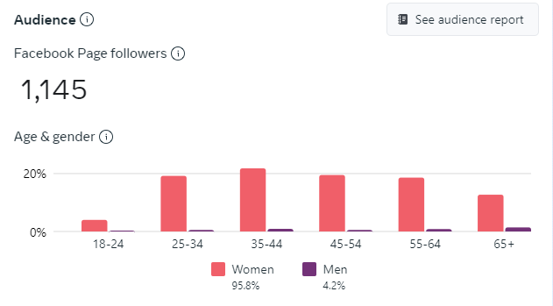
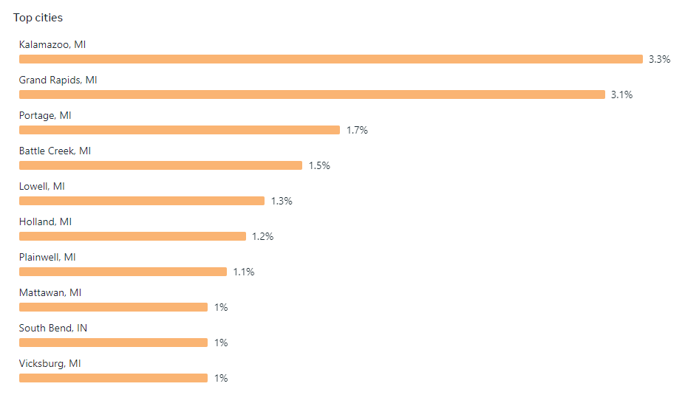

Membership Committee Report – Mary
129 members, of which 58 are new members as of 6/26
Nominations – Abby
Nothing to report
Omnibus committee report – Mary
Gave out all the omnibus this year.
Rules – Janice
Nothing to report
Point Keeper Committee report – Mary
Website is up to date on points.
Show Committee Report – Carmen
Late add – 4 Aberdeen Farm shows. Total of 21 shows on the calendar for 2023.
2023 Shows:
- Wyn Farm – May 6,7
- Pine Lake – May 20
- Rivendell – May 27,28
- Annual Show @ Pine Lake – June 17
- Willow Ridge – June 23,24
- Wyn Farm – July 15,16
- Rainbow Riders / Linda Cooper – July 22
- Aberdeen Farm – July 29, 30
- Countryside – August 6
- Wyn Farm – August 12,13
- Aberdeen Farm – August 27
- Pine Lake – September 9
- Aberdeen Farm – September 17
Show Host Rules
- Email sent out about this. I’m suggesting the following changes to the show host rules for 2024:
  - Removing the in-person show-host meeting. Replacing with a virtual meeting, or just cancelling the meeting since we are working with established shows.
  - Change show host forms/payment deadline to January 31 of each year
  - Change show bills deadline for omnibus to February 14th of each year
  - Change show season to end the last full weekend of September
  - Remove “support at shows” from the list of show host benefits.
  - Change the technical ambassador verbiage to say available via phone if requested by show host.

Show Evaluations – Abby
Going out after each show. Being sent to show hosts after received.
Year End Awards report – Mary
Nothing New to report
Virtual Shows – Tereasa
34 entries in May, 55 entries in June, 51 entries in July
Western Dressage (r) judges were added for June – August shows
Youth – Abby
Nothing new
- Old Business:
Logo – Maria starting to work on ideas. Mary is assisting.
- New Business:
On 7/10 Carmen made the following motion to the board via email:
In honor of GLASS-ED’s 30th anniversary, we host this celebration at Holland Horse Park on September 17th open to members. I also motion that GLASS-ED utilize some of its funds to pay for this celebratory event – the $350 rental fee and food.

Motion seconded by Tereasa. Yes votes from Patti, Maria, Angie, Mary, Abby
The motion passed.

